**SMART WATER SUPPLY MANAGEMENT SYSTEM**

**An Engineering Project in Community Service**

**Phase – II Report**

***Submitted by***

1. **GOPINATH K – 19BEC10003**
2. **MANIN THOMAS T A – 19BEC10026**
3. **CHANDRU T – 19BEC10035**
4. **SANDEEP S – 19BCE10252**
5. **ABISHEK PRABAKARAN RAMKUMAR – 19BCE10275**
6. **PRABHU B – 19BCY10139**

***in partial fulfillment of the requirements for the degree of***

***Bachelor of Engineering and Technology***



**VIT Bhopal University**

**Bhopal**

**Madhya Pradesh**

**APRIL,2022**



**Bonafide Certificate**

Certified that this project report titled **“Smart Water Supply Management System”** is the bonafide work of 19BEC10003 Gopinath K, 19BEC10026, Manin Thomas T A, 19BEC10035 Chandru T, 19BCE10252 Sandeep S, 19BCE10275 Abishek Prabakaran Ramkumar, 19BCY10139 Prabhu B who carried out the project work under my supervision.

This project report (Phase II) is submitted for the Project Viva-Voce examination held on …………..

**Supervisor**

**Comments & Signature ( Reviewer 1)**

**Comments & Signature ( Reviewer 2)**

**Sl. No. Topic Page No.**

1. Introduction 4
   1. Motivation 5
   2. Objective 5
2. Existing Work 6

3. Topic of the work 7

4. Conclusion 18

5. Reference 19

# INTRODUCTION

**Smart Water Supply Management System** refers to a movement of water involving an emerging technology that includes hardware, software, and analytics to help the water and wastewater utilities to solve problems through automation, data gathering, and data analysis.

Smart Water Management System is essentially a designed system to gather the data on the **flow of water, the pressure of the water, and the distribution of a city’s/town’s water.** The main goal is to ensure that the infrastructure and energy used to transport water through a pipeline are managed effectively.

Some of the features of water management include pressure management of water, smarter leakage detection techniques for water networks through the pipeline, smart network operations and maintenance of the water cycle, smart water flowtechnology, and smart water quality monitoring. **Which we have included in this Project.**

The challenges are to this operation, maintenance and increase in safety of the supply of water quality, and at the same time protect the environment and water source.

The main aim of this project is to design and calibrate the existing water management system that will manage the need for the water in Urban as well as the rural areas too.

Water Resources Management is **a process of planning, developing, and managing water resources, in terms of water quantity and quality, across all types of water uses**. It includes the infrastructure, incentives, and information systems that support and guide water management.

Water resource management traditionally involved in managing water storage and water flows. These things are to be done to natural and man-made infrastructures development to enhance water security against the backdrop of rising demand, water scarcity, growing uncertainty of water, and fragmentation challenges.

Reuse or conservation of water helps to recycle the groundwater by reducing the consumption of water and using alternative water sources. This method involves the irrigation of rainwater, groundwater depletion, Greywater reuse, and wastewater recycling.

This Smart water management systems can provide a more resilient and efficient water supply system and, reduce costs to improve sustainability.

This project is totally designed to make the water a useful one instead of wasting it and productively using the water. Even with the wastewater utilities, we can use them for some other purposes.

## **Motivation**

Water management can offer many benefits to society and the environment it can Reduce water and sewer costs, reduce energy usage, and wastewater treatment energy usage.

Smart water systems can reduce the amount of water that is wasted during the agricultural and manufacturing processes, and improve the efficiency of water distribution systems.

This Smart water management System requires various integration of the systems and some productive measures to monitor, control, and regulate the usage of water, quality of water, and as well of to maintain the associated equipment (pipes, pumps, etc.).

There are many hardware and software instruments to be used in this Smart Water Management System which include sensors, meters, data processing tools, and actuators to this water system.

## **Objective**

The objective of this Smart Water Management System is a reasonable and sustainable usage and recycling of water resources. Since the continuous in growing the population, increasing the environmental issues, and pressure on the food and agriculture sectors make the water even a more precious.

**This Smart Water Supply Management System is:**

* To fill the need for water scarcity in the urban areas
* To create a simple and intelligent access system using information technology.
* To develop a rainwater harvesting system in every house and in the possible areas.
* To create a mechanism that would detect the leakage of water and shortage in the water supply system.

# Existing Work / Literature Review

The Water Supply Management System is for most of the developing countries around the world that have different problems. Because of the sudden rise in water demand the water in many areas is facing the problem of water scarcity, especially in dry areas.

Smart Water Management is mainly concentrating on reducing the challenges facing the water sector. Information and communication technologies play a major role in Smart Water Management.

This can maximize the social and economic welfare by integrating ICT products and can be effectively used for continuous monitoring, finding anomalies in the data can be used for optimizing the water distribution network.

Smart water management includes the data and integration using the sensor networks, smart meter, data distribution using WiFi or through the internet, using cloud technologies, modeling, and analyzing.

Smart water management involves connecting intelligent equipment, smart network, and digital solutions. These three components enable water utilities.

Intelligent pieces of equipment include pumps, mixers, treatment technologies, and sensors that can self-optimize to improve performance.

Smart networks collect information across several pieces of equipment to provide real-time, reactive management of the system.

Digital solutions combine the real-time data from equipment with algorithms to provide proactive management of the system.

Water quality monitoring is an assortment of data sets or desired places and at periodic intervals for providing information that might be accustomed to describing present conditions of the water.

* This smart water quality monitoring system is:

•To measure the quality metrics like physical, chemical, and microbial properties.

•To find the deviations in measured metrics and give timely warning in recognition of threats or hazards.

•To provide real-time analysis of the sensor data and recommend appropriate corrective measures.

# Topic of the work

1. **System Design / Architectures:**

**Main model System design:**

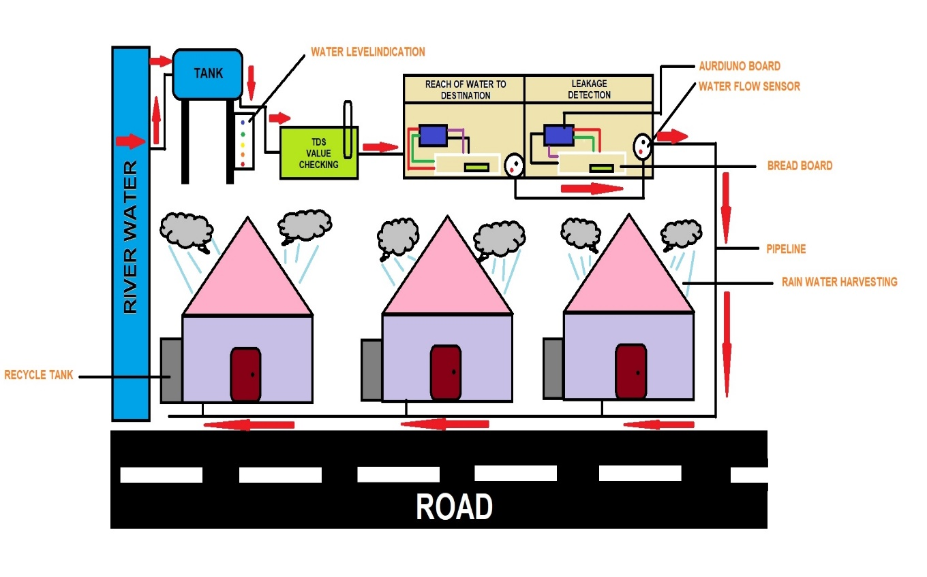

**Fig 1. Architecture**

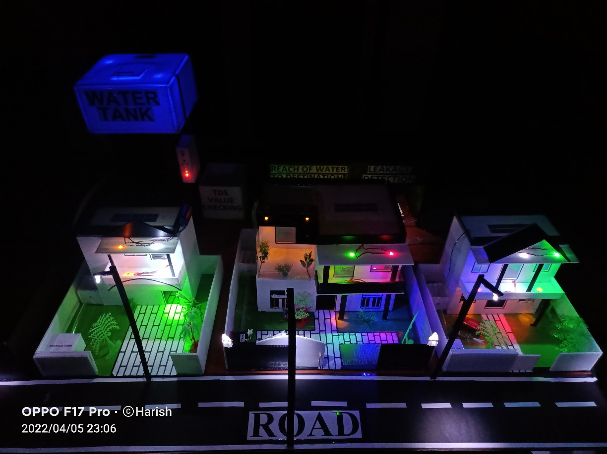

**Fig 2. System Design**

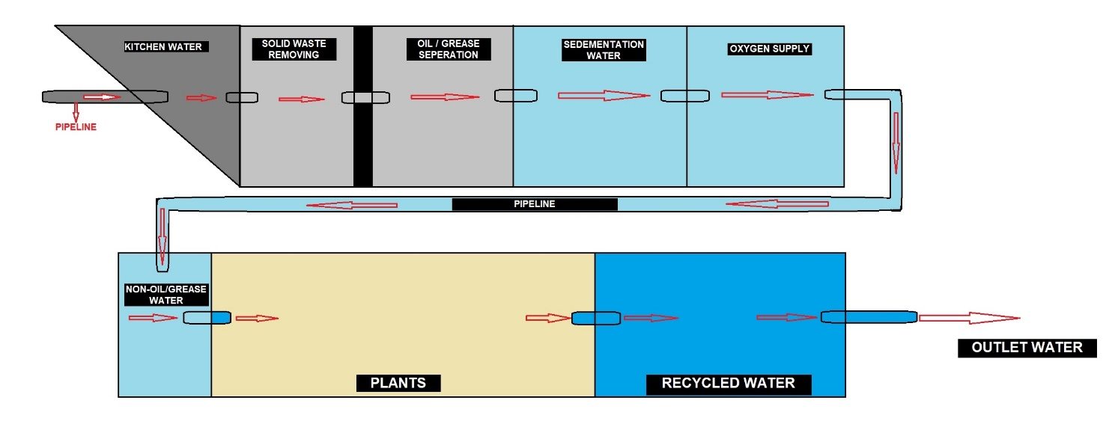

**Fig 3. Recycle Tank Architecture**

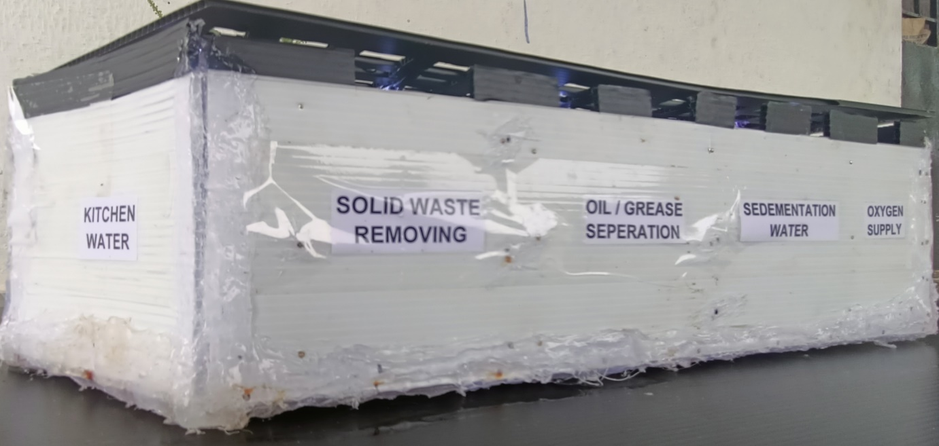

**Fig 4. Recycle Tank System Design**

1. **Working Principle:**

* This project Smart Water Supply Management System has a total of 6 topics including all the methodology used in this project.

1. Water Level Identification
2. Purity of water
3. Reach of water to the destination
4. Leakage detection
5. Rainwater harvesting
6. Water recycle tank
7. **Water Level Identification:**

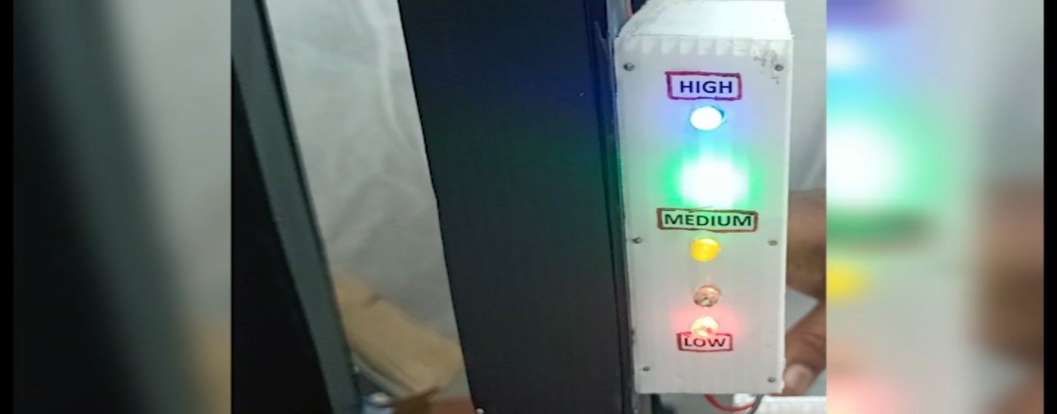This Water level identification system is used to measure and identify the water level. We can do this water level indicator using LEDs, a battery, and some wire connections. Which will be useful to save water instead of overflowing. When a certain amount of water is filled in the tank, we can switch off the motor. Hence the water will not get wasted.

While installing these Water Level Indicators has the following benefits:

1. Save power

2. Save money

3. Electronic design reliable

4. Easy installation

1. **Purity of water:**

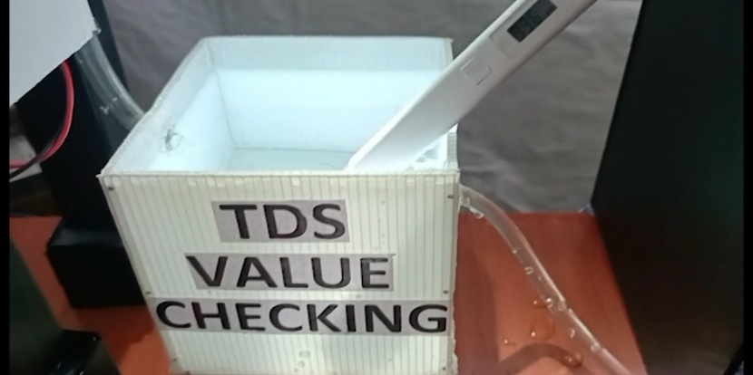This Purity of water is checked using the TDS value (TDS is an abbreviation for Total Dissolved Solids) in a liquid. TDS is generally expressed in (ppm) or as milligrams per liter (mg/L). A TDS meter is an electrical charge (EC) meter whereby two electrodes equally spaced apart are inserted into the water and used to measure the charge. The result is interpreted by the TDS meter and converted into a ppm figure.

If the water contains no soluble materials and is pure, it will not conduct a charge and will, therefore, have a 0 ppm figure. Similarly, if the water is full of dissolved materials, it will conduct a charge, with the resulting ppm figure being proportional to the number of dissolved solids.

1. **Reach of water to the destination:**

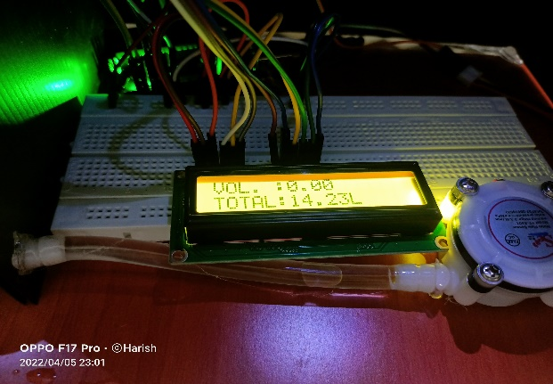**Reach of water** to the destination is a system where it detects the amount of flow of water. This system recognizes it with the help of a water flow sensor. This sensor reads the data like how many liters of water have been sent. This system is to measure the water flow without contact with water. It is suitable for plastic and metal pipes. The low-cost water flow detection system is most useful for domestic purposes. It detects the flow-induced vibration signal from the flow of water in the pipe. It converts flow-induced vibrations due to water flow inside the pipe into electrical signals.

1. **Leakage detection:**

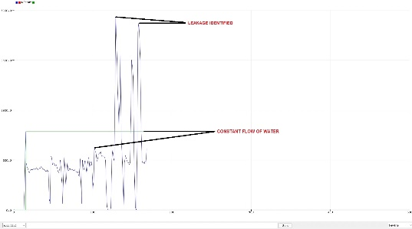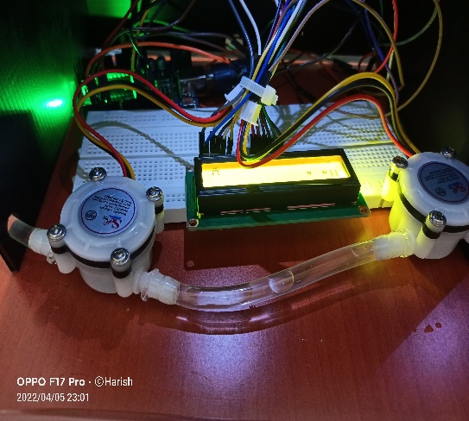This Leakage detection system finds the water leakage at a particular point. So, for this, we have demonstrated a leakage of water in the pipeline. Hence through the graph, we can determine whether the water is going in a constant flow or some leakage is happening. If there is a leakage, we can stop the water flow. In the graph, how we can find the leakage is for a constant flow of water the peak level of the graph constantly moves at a particular point. Whereas in the type of leakage that happened in the pipeline, the water flows fast and the graph also goes to the highest peak point.

1. **Rainwater harvesting:**

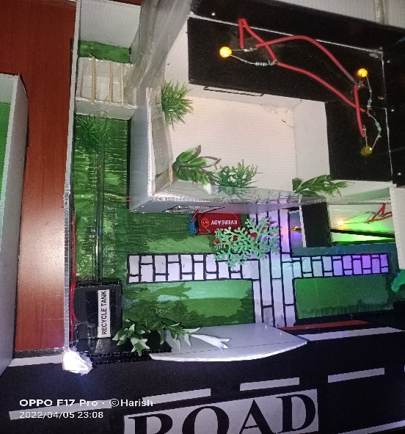Rainwater harvesting is one of the precious methods to solve water scarcity. This system is built in every house in this model. The collected rainwater is filtered in the recycle tank and later it is used for various types of utilities like gardening, irrigation purpose, and for some other domestic purposes.

1. **Water recycle tank:**

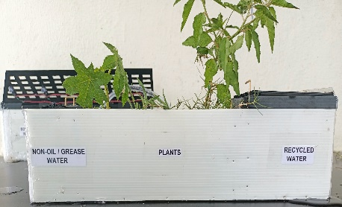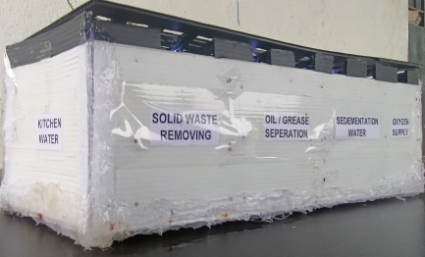This is the main process of this model where the used water like kitchen, bathroom, washing clothes and all these types of water can be used for recycle purpose. This recycle tank is designed in a way of eight chambers. Starting from the **Kitchen water Solid waste removing Oil / Grease separation Sedimentation process Oxygen supply Non- Oil / Grease water Plants Recycled water**. With the help of these process the water is been purified in the last stage in that recycled water we can leave some fishes in it. Hence it will not form any bacteria, mosquitos etc. Thus, it helps to purify and have a better quality of recycled water. This recycled water can be used for various purpose for gardening, irrigation etc.

1. **Results and Discussion:**

Starting process from the beginning.

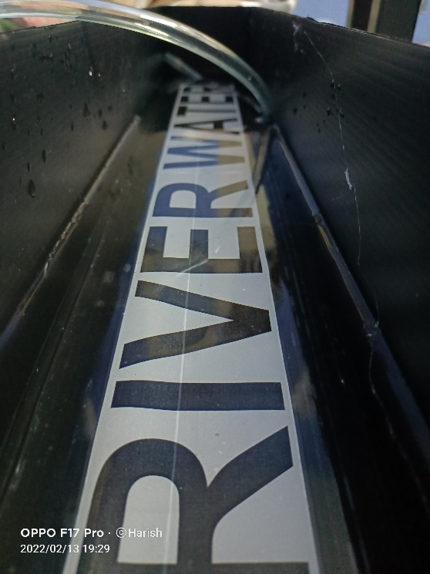

**Fig 5. River water**

The main source of water is taken from River / Dam

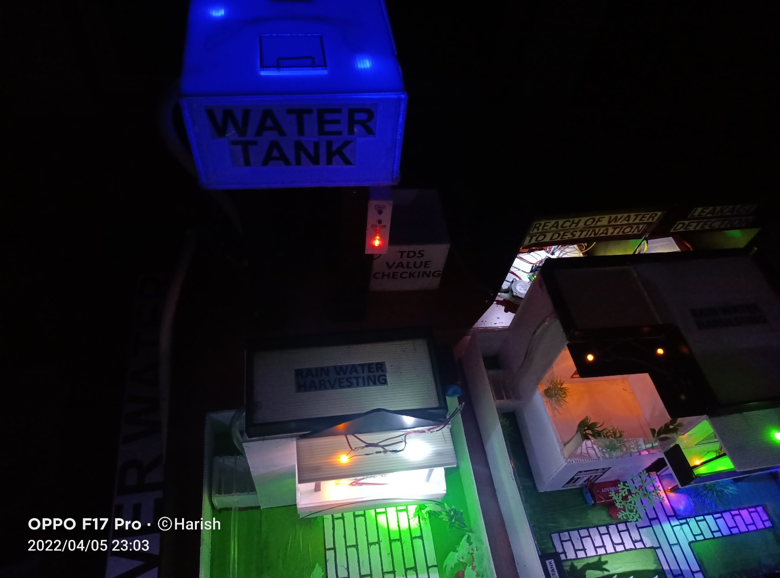

**Fig 6. Water Tank**

Taken water is been filled to the water tank

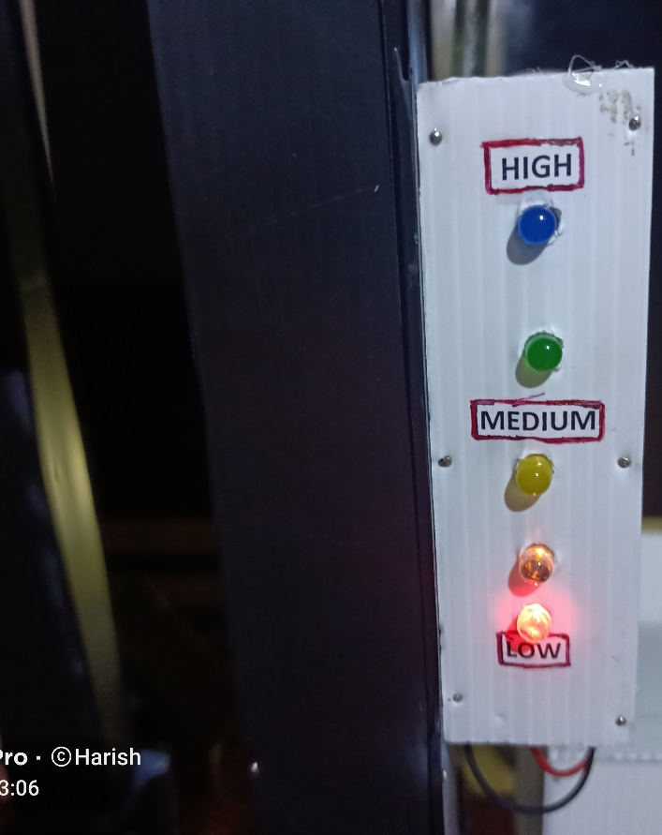

**Fig 7. Water Level Indicator**

This water level indicator is fixed near the pillar of the tank with the help of wires in the tank this water level indicator shows us the current level of the water.

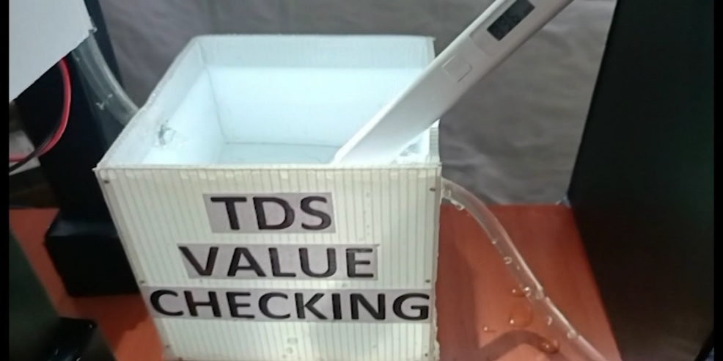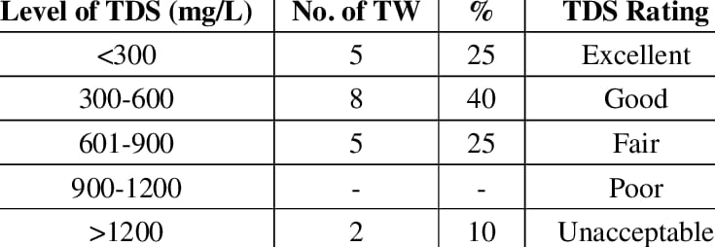

**Fig 8. TDS Value Chart Fig 9. TDS Value of water checking**

TDS meter helps us check whether the quality of water is good or not the current value of this water TDS value is 396 ppm. Hence it is suitable for drinking and good water.

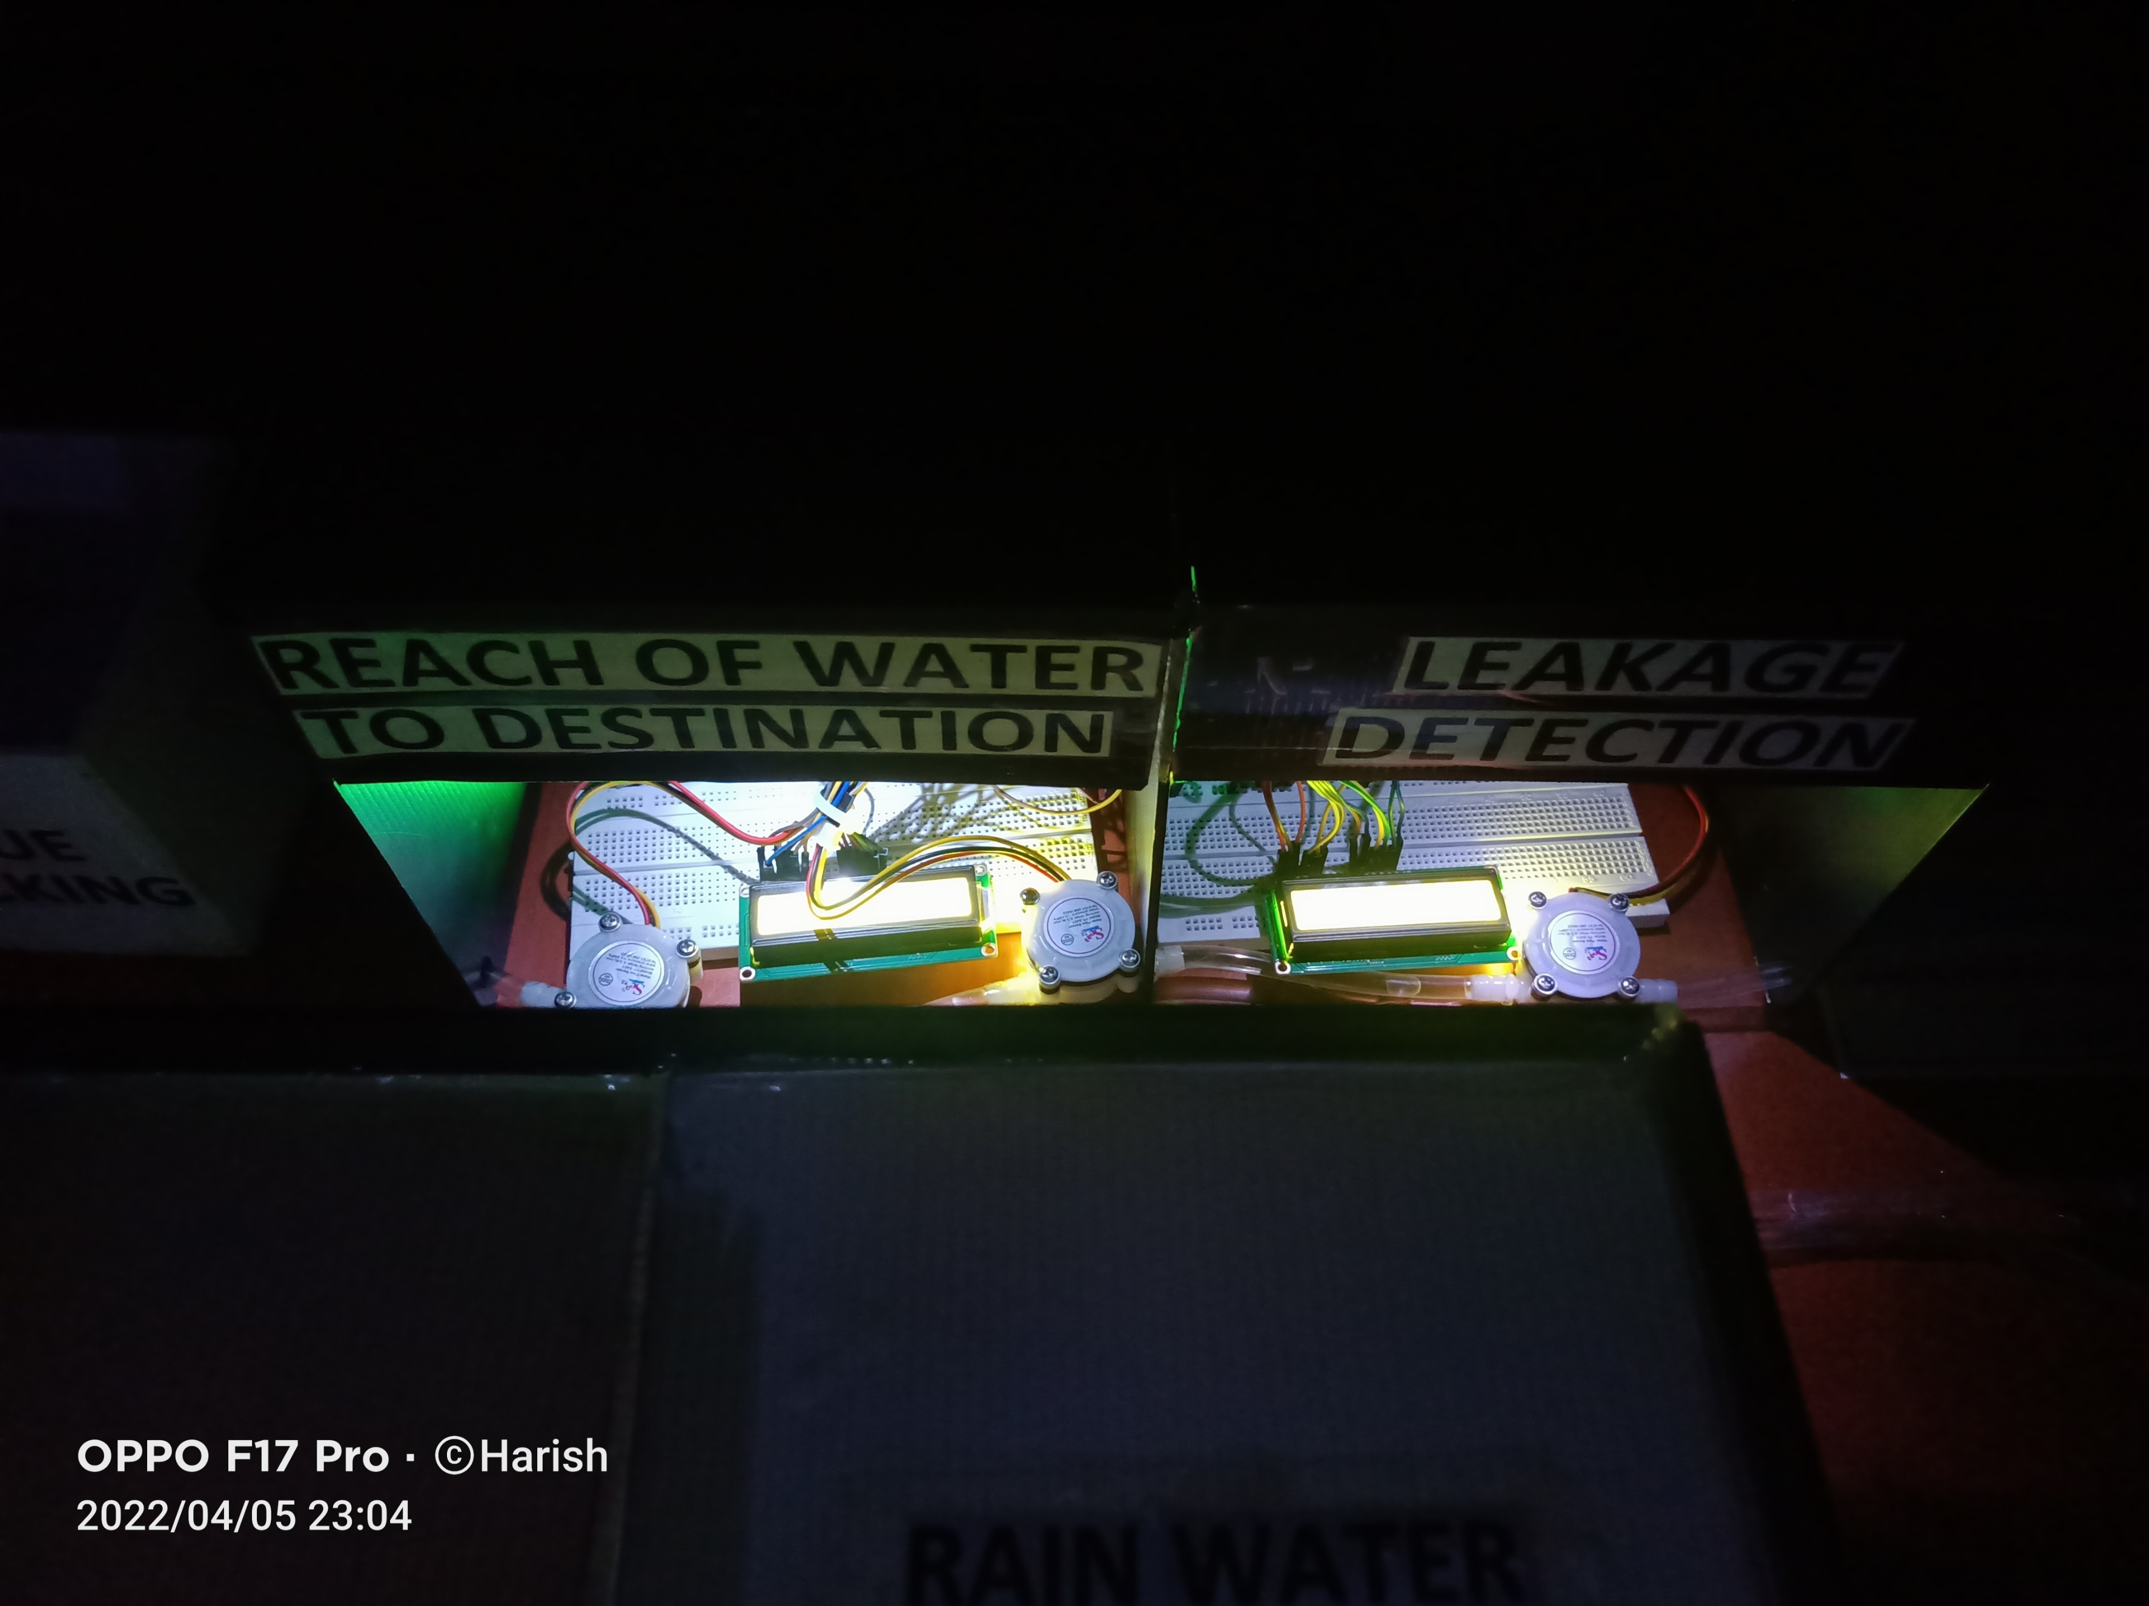

**Fig 10. Reach of water to the destination system**

This Reach of water to the destination system detects the amount of flow of water as well as the total volume of water sent and similarly, we can find whether someone is extracting the water. So, now the system shows the current Volume of water flowing and the Total amount of water sent.

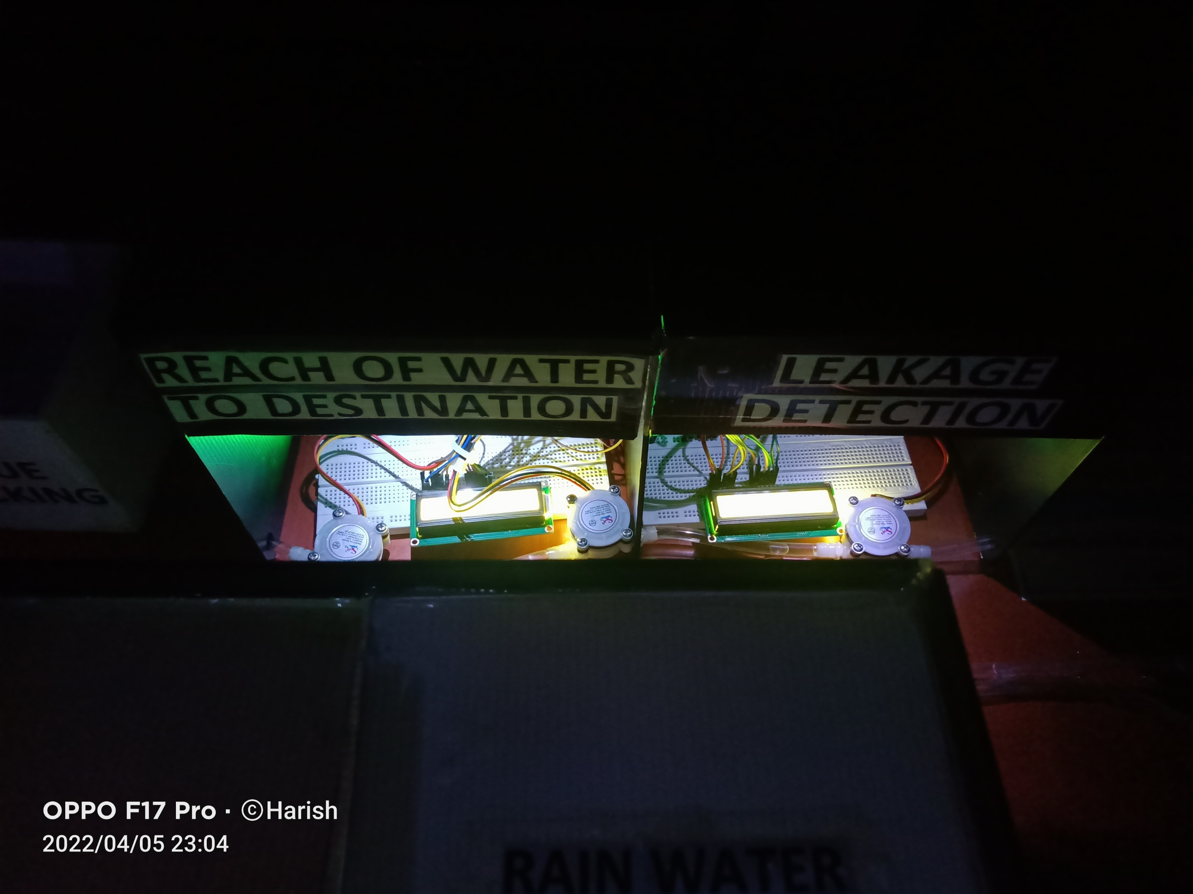

**Fig 11. Leakage Detection**

This Leakage Detection system ensures that whether the water is going in a constant flow or any other leakage is happening or happened.



**Fig 12. Leakage Detection graph**

Since, we have demonstrated a sample leakage detection in the pipe the graph reaches the highest peak level. Hence, we can decide there is some leakage. If the water is flowing normally the graph goes constantly.

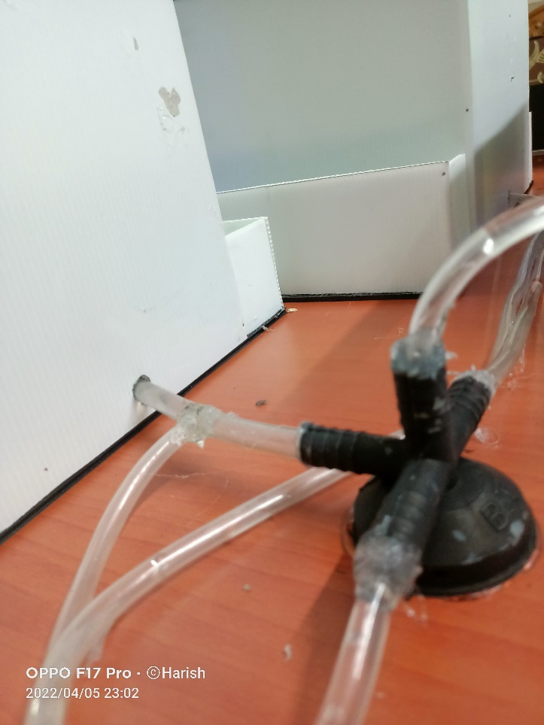

**Fig 13. Pipeline connection to houses**

We have made a good and a smart way of pipeline connnection to the houses.

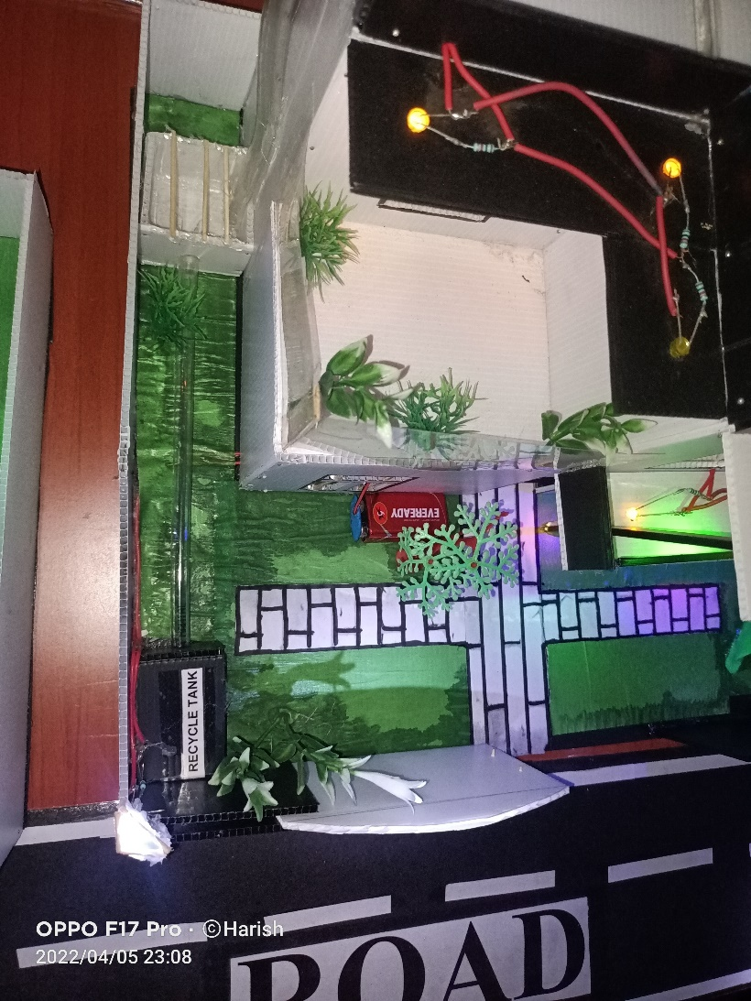

**Fig 12. Rain water harvesting System**

Rain water harvesting is the main system where it helps us in the water scarcity period. So, here we have designed like when the water comes on the terrace the water is allowed to a small pit. That pit is directly connected to the recycle tank and that tank purifies the water.



**Fig 13. Recycle Tank**

This Recycle tank consits of 8 chambers in it followed by various methodologies the final result of this tank gives us the purified water. Which can be used for other utilities like gardening, irrigation, car washing etc.

1. **Individual Contribution by members:**

As a result of my contribution to the **Smart Water Supply Management System** Project was:

* The drafting of architectural artwork in the Main model and Recycle tank. On a computer, I digitalized the design and drew the main model and the recycle tank.
* Giving the concept of implementation and the method of construction of the main model and recycling tank.
* Giving various ideas and different methodologies to implement the working modules.
* Categorizing the materials needed for the whole project and making the budget plan.
* I completed the existing project and made it operational. Built a water tank out of corrugated sheets and turned it into a working one. A water level indication schematic was been made.
* Reach of water to the destination system and leakage detection systems connections were made to the Arduino UNO board, and LCD display connections were properly connected from the breadboard.
* Accomplishment of pipeline connections to each house was made. A study was done on water flow sensor then it’s working. Finally, selected which sensor to buy for this specific model.
* In addition to it, some extra features were been added to the main model to make it more decorative. Like (Lighting for street lights, house lighting, the Reach of water to the destination system, and leakage detection systems room lighting.
* Each house was built and its electrical connections were properly connected through wires and a battery.
* Implementing the Recycle tank model with various chamber designs under lighting conditions and making it an operational one.
* Making Animations and adding content to the presentation to showcase the project which we have done.
* Organised meetings and conferred about various ideas with my teammates to make this project a successful one.

# CONCLUSION:

In this project, we created a system to control the supply system's variables such as water pressure, water quality, and water pollution.

This Water Supply Management System managed and supplied the need for water in urban areas, as well as meeting the need for water in urban areas. A rainwater harvesting system was built near each house for future use.

A smart mechanism was developed to detect the source of leaks and water shortages in the supply system.

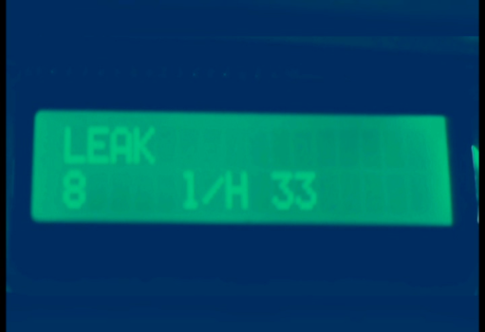A major module in Leakage Detection in Water Distribution System is successfully implemented in this research work; water leakage is detected by the system by processing the signal from the sensor and thus notifying the leakage through the graph, which helps to respond to the leakage as soon as possible. A leakage attempt has been made, and as a result, the display shows a **leak.**

As the Reach of water to the destination system is built in this project it gives the display like how many liters of water has gone and the total amount of water flowed to the destination is been shown.

Since water level indication has been implemented in this project, the same concept can be applied to a large number of distribution tanks and consumers. The smart water distribution and management system proposed here can be used in smart cities.

# Reference:

1. M.V. Pavankumar, A.B. Kumbhar, P.H. Prasad, S.B. Prashant and P.V. Akshay, “Automated Town Water Management System,” International Journal of Research in Advent Technology, vol. 2, no. 4, pp. 132-134, April 2014.

2.Anzaldi, G. (2014). A Holistic ICT Solution to Improve Matching between Supply and Demand over the Water Supply Distribution Chain. J. sustain. dev. energy water environ. syst, 2 (4), 362-375. Carlisle, D. (2010, April). graphicx: Enhanced support for graphics. Retrieved from

3.N.B. Bhawakar, D.P. Pande, R.S. Sonone, M. Aaquib, P.A. Pandit and P.D. Patil, “Literature Review for Automated Water Supply with monitoring the performance System,” International Journal of Current Engineering and Technology, vol. 4, no. 5, pp. 3328-3331, October 2014.

4.Philippe Gourbesville, Lian Guey Ler, "Framework implementation for smart water Management", September 2018

5.M. Saraswati, E. Kuantama and P. Mardjoko, “Design and construction of water level measurement system accessible through SMS,” Proc. in 2012 Sixth UKSim/AMSS European Symposium on Computer Modeling and Simulation, Valetta, Malta, November 2012.

6.V. Vaishnavi, R.C. Varshitha, M. Tejaswini, N.R. Biju and K. Kumar, "Literature Survey on Smart Water Quality Monitoring System,” International Journal of Innovations in Engineering and Science, vol. 3, no. 3, pp. 20-24, 2018.

7.N.Kedia, “Water Quality Monitoring for Rural Areas-A Sensor Cloud Based Economical Project,” Proc. in 1st International Conference on Next Generation Computing Technologies (NGCT-2015) Dehradun, India, 4-5 September 2015.

8.N.A. Cleote, R. Malekian and L. Nair, “Design of smart sensors for real-time water quality monitoring,” IEEE Access, vol. 4, no. 9, pp. 3975 – 3990, July 2016.

9.V.V. Daigavane and M.A.Gaikwad, “Water Quality Monitoring System Based on IOT,” vol. 10, no. 5, pp. 1107-1116, 2017.

10. Detecting and locating leaks in Underground Water Mains Using Thermography - January 2009 Contactless Running Water Flow Detection and Water Flow Measurement System Vol. 7 Issue 04, April-2018